**Root Finding,**

|  |  |  |  |  |  |
| --- | --- | --- | --- | --- | --- |
| Method | Description | When to Use | Disadvantages | Advantages | Open/Close |
| Bisection | Divides an interval in half and selects the subinterval in which a root must lie. | Continuous functions with known signs at the interval ends. | Slow convergence for some functions. | Simple and reliable. | Closed |
| False Position | Similar to bisection but uses a linear interpolation. | Continuous functions with known signs at the interval ends. | Can converge slowly if one endpoint always yields the same sign. | Usually faster than bisection. | Closed |
| Golden Search Method | Uses golden ratio to find minima/maxima, applicable for root finding by reformulating the problem. | Unimodal functions in a specified interval. | Slower compared to other methods for function optimization. | Does not require derivative information. | Closed |
| Inverse Quadratic Interpolation | Uses an inverse quadratic model to approximate the root. | Functions that are difficult for other methods due to oscillation or slow convergence. | Complex and can diverge if not properly applied. | Can be very fast for some functions. | Open |
| Modified False Position | A variation of the false position method with adjusted interval selection criteria. | Similar to false position, when standard method converges slowly. | Requires more computation per iteration than standard false position. | Improves convergence speed compared to standard false position. | Closed |
| Muller | Uses a quadratic interpolation for root finding. | Functions where derivative information is not available or unreliable. | Can be less stable. | General-purpose and can handle complex roots. | Open |
| Naive Line Search | A simplistic approach, often involving stepping through a range of values. | Simple unimodal functions. | Inefficient and not precise. | Easy to implement. | Open |
| Newton | Uses function and derivative to iteratively converge to the root. | Functions where derivatives are known and continuous. | Requires derivative, can diverge if initial guess is poor. | Fast convergence for well-behaved functions. | Open |
| Secant | Similar to Newton but approximates derivative. | When the derivative is difficult to compute. | Can fail to converge for poor initial guesses. | Does not require explicit derivative. | Open |
| Single Fixed Point Iteration | Transforms the equation into x = g(x) and iteratively solves. | Functions that can be transformed into a stable fixed-point iteration. | Can converge very slowly or diverge. | Simple to understand and implement. | Open |

Horner Quartic - Efficient polynomial evaluation and root finding method, often used in combination with other methods.

Synthetic Division poly - Used for polynomial root finding by iteratively reducing polynomial order.

Bisection Step by Step,

False Position,

Newton Raphson,

Secant, Secant vs False Position,

**Regression + Interpolation**,

Data is often available at discrete point along a continuum, but we may require estimates points between the discrete values. We may require a simplified version of a complicated function: Compute values of the function at several discrete values fit a simpler function to these values.

Regression - if discrete exhibits a significant error or “noise”. We make no effort to intersect every point. Rather, the curve is designed to follow the pattern of the points taken as a group.

Interpolation – Data is known to be precise. Fit a curve (or a series of curves) that passes directly through each of the points.

Linear Regression Analytical Method,

Equation (1) - Slope (a1​): This equation calculates the slope of the best-fit line, representing the average change in y for each unit change in x, based on the covariance of x and y relative to the variance of x.

Equation (2) - Intercept (a0​): This equation determines the y-intercept of the best-fit line, which is the expected value of y when x is zero, calculated by adjusting the mean of y by the slope times the mean of x.

Equation (3) - Linear Equation: This is the linear equation y=a0​+a1​x that represents the best-fit line, allowing for the prediction of y from any value of x using the intercept and slope derived from the data.

Summary:

In summary, these formulas are used to find the line of best fit in a set of data, where the line has the equation y=a0​+a1​x. The line tries to minimize the distances (errors) between the actual data points and the predictions made by the linear model.

|  |  |  |  |
| --- | --- | --- | --- |
| Method | How it works | When to Use | Advantages |
| Linear Regression | Fitting straight line to data,  The code utilizes the Ordinary Least Squares (OLS) method to perform linear regression. It finds the best-fitting linear relationship between the independent and dependent variables. | establishing a linear relationship between variables. | Simplicity:  insights into relationships  *sensitive to outliers  *assumes linear relationship |
| Polynomial Regression | Fitting curved line to data,  The code performs polynomial fitting using the method of least squares. It fits a polynomial to the given data points using the specified degree. It uses the **np.polyfit** method to perform the polynomial fitting. | Suitable for fitting data that exhibits a polynomial trend. | Fit complex curves by using higher-degree polynomials.  Simple and flexible model for data approximation.  *sensitive to outliers |
| Polynomial Interpolation | Sample Equation at two locations,   | Estimate Intermediate values | *smaller interval better approximation  A graph of interpolated value  Description automatically generated*not always bet second order is more accurate |
| Spline Interpolation | Special type of piecewise polynomial,  Local interpolation – lower order poly  *less points are used | Fits low degree polynomial to small subset of values | -Flexible + Powerful Interpolation  -Avoid the oscillatory behaviour that occurs if we fit a single high order polynomial |

**Linear Algebra,**

|  |  |  |  |
| --- | --- | --- | --- |
| Method | How it works | When to use | Advantages |
| Cramer Rule | Arrange formula Ax=b,  Find the Determinant, if det = 0, the,  -system singular,  -Cramer cant be applied  No solution  Det ~ 0   * Ill conditioned * Almost singular   A black background with white text  Description automatically generated | Three equation  Where a solution exist  Aplicable only to square system  Square system #equation=#unkown | Not computational efficient when more than 3 equation |
| Naïve Gauss Elimination | 1-Form Augmented Matrix  2-**Forward Elimination** Make matrix an uppor triangle  3-Backwards substitute finding coefficient where the rest is 0 | System of linear equation | -Will crash as they are not able to handle division by 0  -Can Accumulate inaccuracis due to round-off error  -ill conditioned systems not suited for NGE because round-off errro |

Solution to Improve,

-Use more significant figures

- Use of partial or full pivoting

**ODE**

|  |  |  |  |
| --- | --- | --- | --- |
| Method | How it Works | Uuse | Advantages/Disadvantage |
| Euler | Given dy/dx=f(x,y) with initial conditions y(x0)=y0 approximates solution by linearly extrapolating the slope of the curve.   1. Take your initial condition as your starting point, y(x0)=y0 2. Take dy/dx=f(x,y) where f(x,y) is the function that describes the slope at any point and find the slope at the starting point, for f(x0, y0) 3. Linear Extrapolation – Euler method assumes the slope remains constant over small interval, therefore you project the curve forward from (x0, y0) with slope, done using this formula (h=stepsize) 4. A math equation with black text     Description automatically generated with medium confidenceNew point calucaltion, by applying this formula you find the next point x1,y1 for which x1=x0 and y1=y0+f(x0,y0)h, giving you approx. value for y at x1 | simple problems where precision is not needed | **Advantages**,  Simple, easy to understand and implement  **Disadvantages**  Can be inaccurate especially for stiff ODEs, or when large step size are used, as the error accumulates with each step (not good for high precision |
| Implicit or Backwards Euler Method | A math equations and formulas  Description automatically generated with medium confidenceimplicit because yi is on both side of the equation,  to solve this, invert the formula and do so by finding its roots | For all Stiff ODE  (when stability is more important than precision) | Euler – overshoots the exact solution  Implicit – undershoots the exact solution  High computational cost per step |
| Stiff Euler | Euler method but with adaptive step size, changes the step size h for different intervals of x, depdnding on fast or slow part of function,  Fast = smaller h, Slow = larger h | For Stiff ODE  (but can be bad for severe stiff ODE) | allows larger steps in smoother regions of the solution, reducing computation time without losing accuracy. |
| 4th order runge Kutta Method | A math equations on a white background  Description automatically generatedA black text with black letters  Description automatically generated with medium confidenceImproves accuracy of euler method, does so by calculating multiple slopes (k values) at different points within each step and then takes the average of the slopes for the final result, | For more complex ODE, to be more accurate | Advantages  More accurate even with bigger step size + do not require the calculation of higher order derivates  Disadvantages  More complex to program |

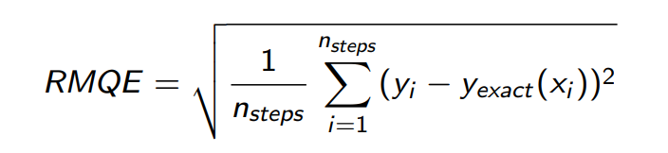**Root Mean Square Error** (RMSE) = measure error of model when predicting quantitive data – good for comparing different models,

Where yi= numerical solution, at the location xi, and yexact(xi) is the analytical solution at xi). Nsteps are the number of steps preformed in each method.

**Truncation error** = the difference between the exact value of the function and the valley obtained from the finite series, if we truncate the series after a finite number of terms.

Truncate series = series that has been truncated meaning that it has been shortened or cut, Eg. if you have a Taylor series for a function, truncating it after the third term, and approximating the function.

**Stiff Equation:** A differential equation where certain components of the solution change much more rapidly than others, leading to a mix of very fast and very slow dynamics in the system. This characteristic necessitates extremely small step sizes for numerical stability in explicit solution methods, making such equations computationally challenging. Stiff equations are common in fields like chemical kinetics and control systems. They are best handled with implicit numerical methods, which can maintain stability and efficiency even with larger step sizes.

**Integration**, - four main variations of quadrature for numerical integration,

Quadrature technique=integration of a function by calculation of area under the curve

Accuracy of methods,

|  |  |  |  |
| --- | --- | --- | --- |
| Method | How it works | Visual Representation | Accuracy |
| Rectangle/Midpoint Rule | A screenshot of a graph  Description automatically generated-Divide into sections, and approximating area using rectanlges |  | Least Accurate |
| Trapezoidal Rule | -Approximate Area under curve using series of trapizodes instead of rectangles |  | Least Accurate |
| Composite Simpson Rule | A screenshot of a graph  Description automatically generated  -Dividing interval into even segments  -applying quadratic parabola to segments  -Calucalting area under polynomial  h= width of interval  n=number of segments |  | Most Accuarte, |

Main Quadrature Techniques,

**Simpson** uses, quadratic polynomials to approximate the function in each subinterval. This higher-order approximation makes it smoother. + Error Bound: The error in Simpson's Rule depends on the fourth derivative of the function, meaning that if the function is well-behaved and its fourth derivative is small or zero

**Midpoint**, uses the value at the middle of each interval, which often provides a better fit than the Trapezoidal Rule for non-linear functions. + Error Bound: depends second derivative For functions with limited curvature, this can result in a reasonably accurate approximation

**Trapezoidal**, using linear interpolation between the endpoints of each interval.

Rectangle Rule Python,

Trapezoidal Rule,

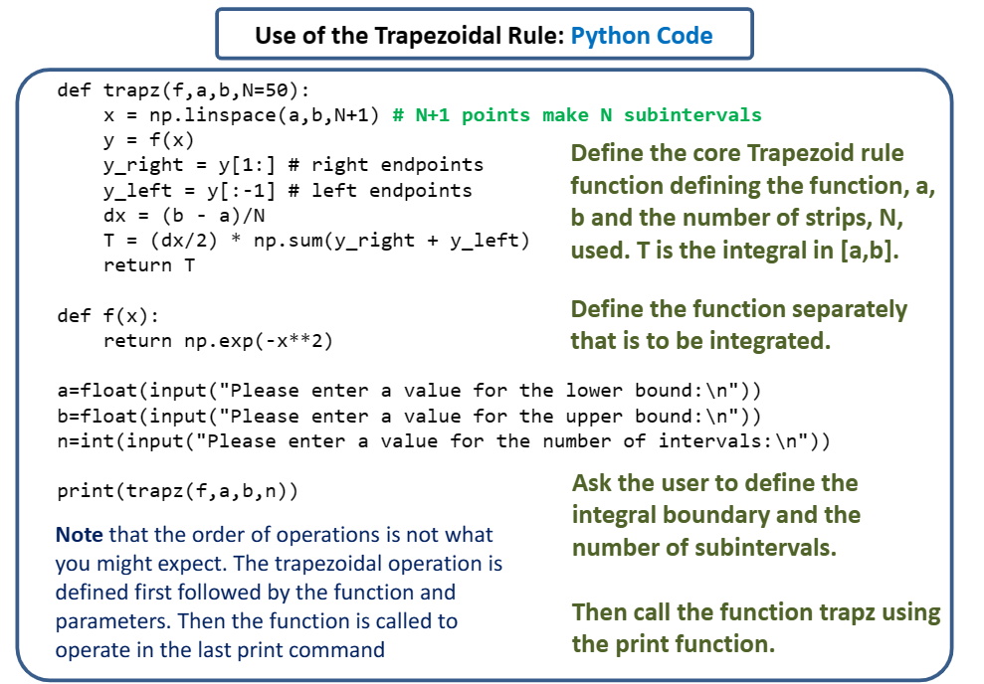

Simpson Rule Python

**Three Eights Simpson Rule –** Varient of Simpson,

-Used when intervals divided into odd n segments.

-Used when the number of segments n is not divisible by 2

Accuracy: like standard Simpson more accurate than the trapezoidal rule for functions well approx. polynomials. Accuracy depends on the nature of function + size of segments

**Adaptive Algorithm – Numerical Method** – Allow intervals to be subdivided if accuracy is not achieved after n steps

* Therefore can be applied to any approach
* Saves Computation time

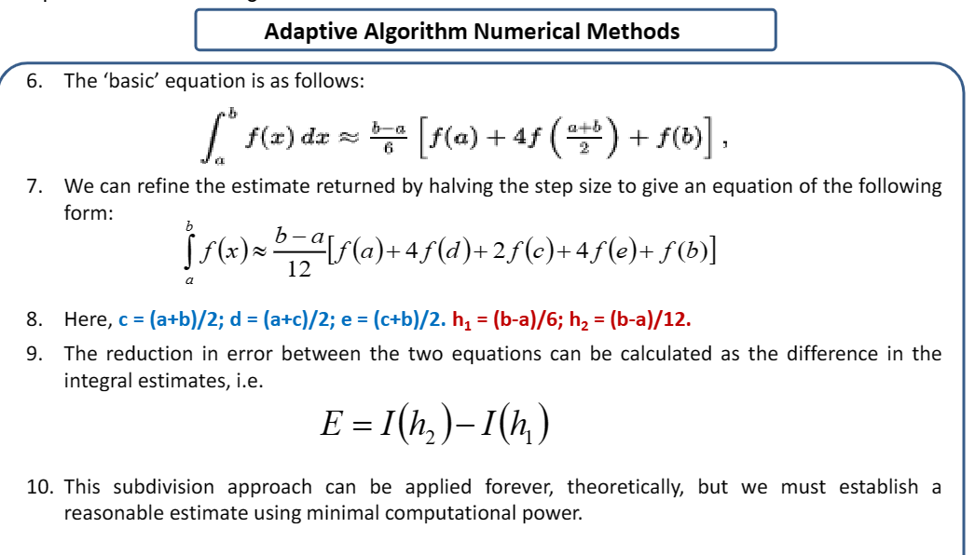Simpson to Simpson Adaptive,